**PROVE Tool – Installation and Setup Manual**

**By: Avi Shaked**

**Revision: 27/4/2020**

# Prerequisites

The following are required:

1. Oracle’s Java Runtime Environment (JRE), version 8.

<https://www.oracle.com/java/technologies/javase-jre8-downloads.html>

1. An Eclipse-Sirius distribution.

Recommended distributions:

**Eclipse IDE** <https://www.eclipse.org/downloads/>

**Obeo Designer Community** <https://www.obeodesigner.com/en/download>

***Note:*** *PROVE Tool was verified to be compatible with the following Eclipse distributions:*

*Eclipse IDE 2020-03 , Obeo Designer Community 11.3*

# Basic Eclipse-Sirius preparation

This section explains novice users how to open the Eclipse-Sirius modeling platform.

1. Go to the Eclipse distribution directory.
2. Run the distribution’s primary executable (e.g., eclipse.exe).
3. Select the directory for your workspace when prompted (you may input a new directory), and press “Launch”.

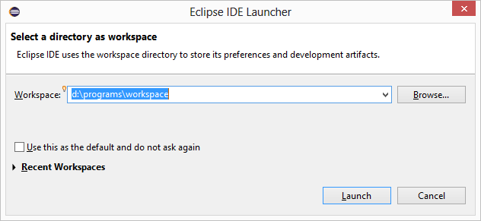

1. Wait until the environment is fully loaded (welcome screen may differ). Close the “Welcome screen by pressing the “X” of the tab. 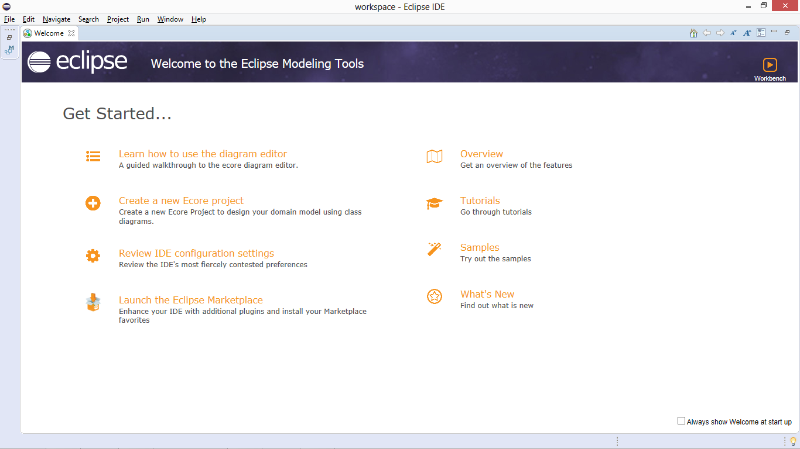
2. Your IDE should become visible.

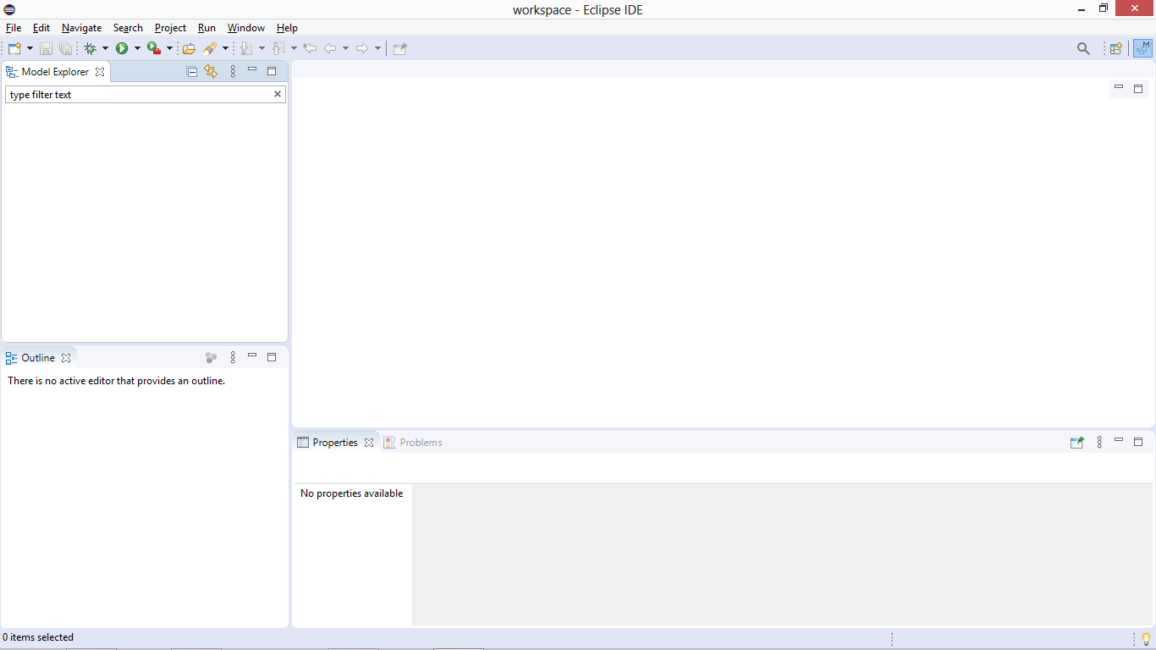

# PROVE Tool Installation

Perform the following:

1. Download the PROVE Tool Archive file **(**[**https://github.com/TAU-SERI/PROVE/**](https://github.com/TAU-SERI/PROVE/)**)**
2. From “Help” menu, select “Install New Software…” (the notation “Help”->”Install New Software…” is used henceforth).
3. For first-time installation: in the “Install” dialogue, Select “Add”->”Archive…” and select the PROVE Tool Archive file you downloaded. Name the repository (e.g., “PROVE Tool Archive”), and press “Add”.

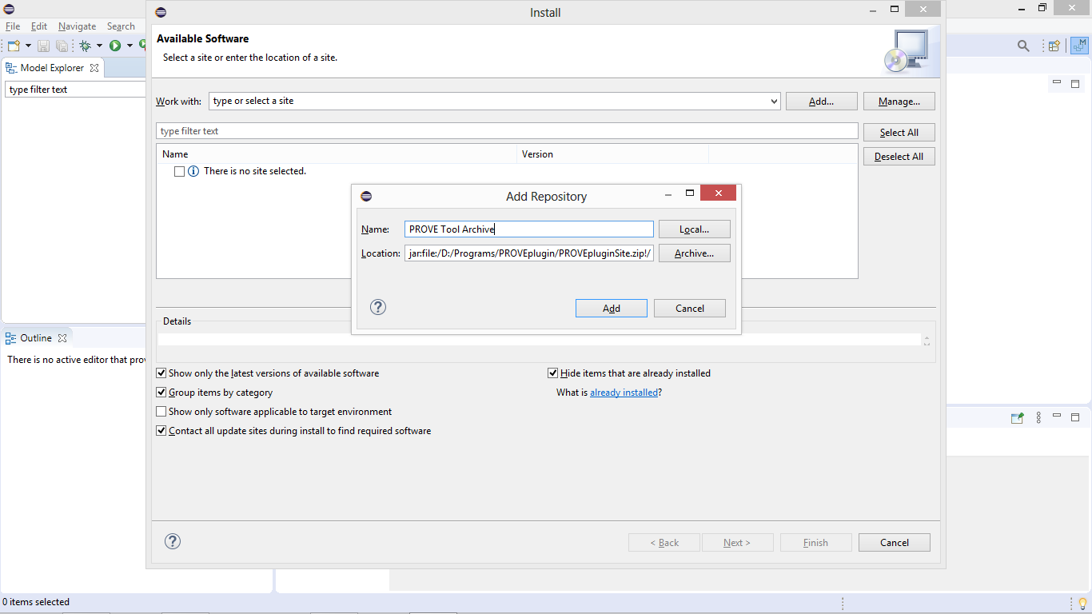

1. Select the repository from the “Work with” selection line. The update site’s content should appear:

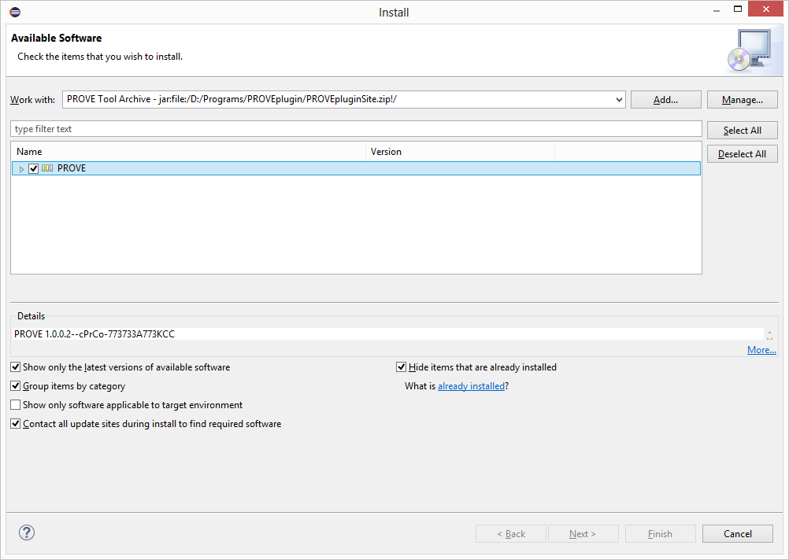

Make sure “PROVE” is selected and press “Next” to install.

1. Approve the installation if prompted by additional dialogues. Eventually, approve restarting the Eclipse IDE.
2. “Help”->”About”->”Installation Details”

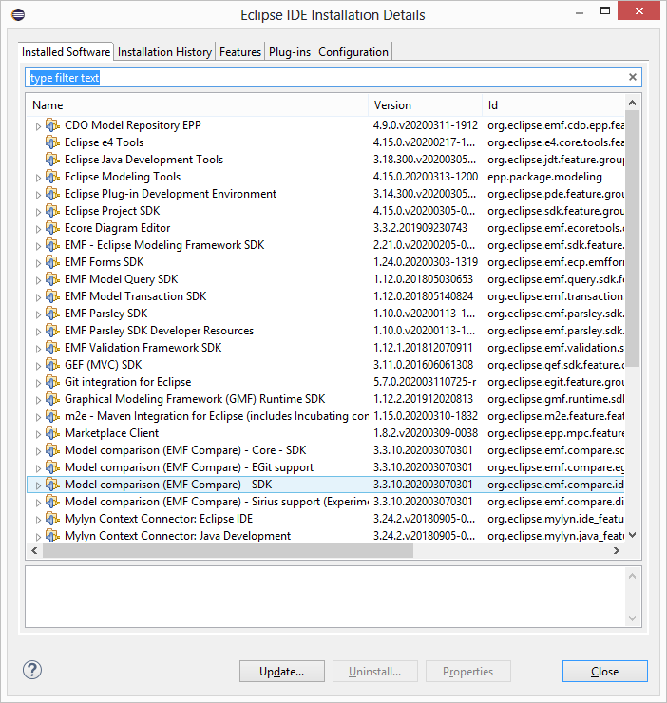

1. Type “PROVE” and verify the PROVE extension was successfully installed.

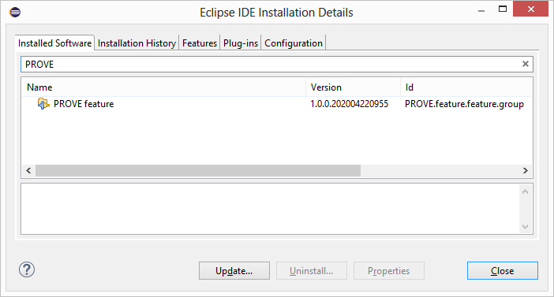

# Creating a new PROVE model

1. File->New->Project…
2. Type “Modeling Project” and select “Modeling Project” under the Sirius folder. Press “Next”.

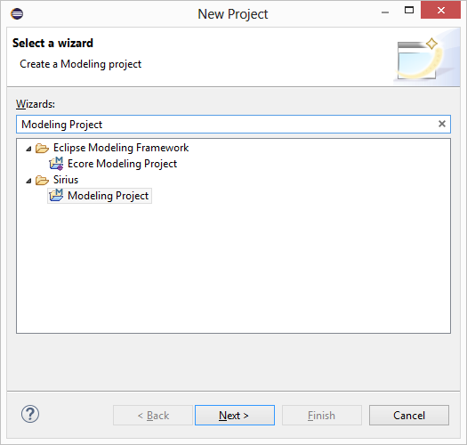

1. Name the project and press “Finish”.

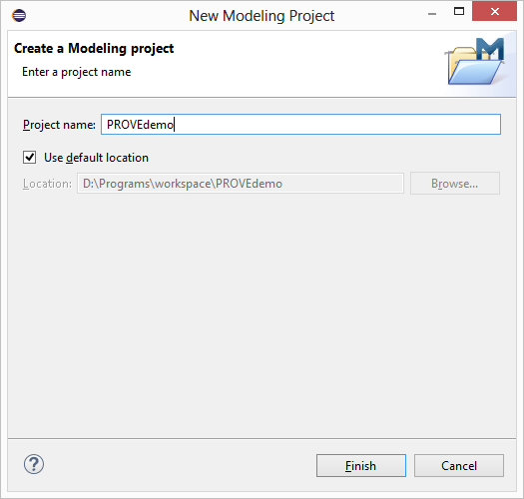

The new project should be available in the “Model explorer” window section.

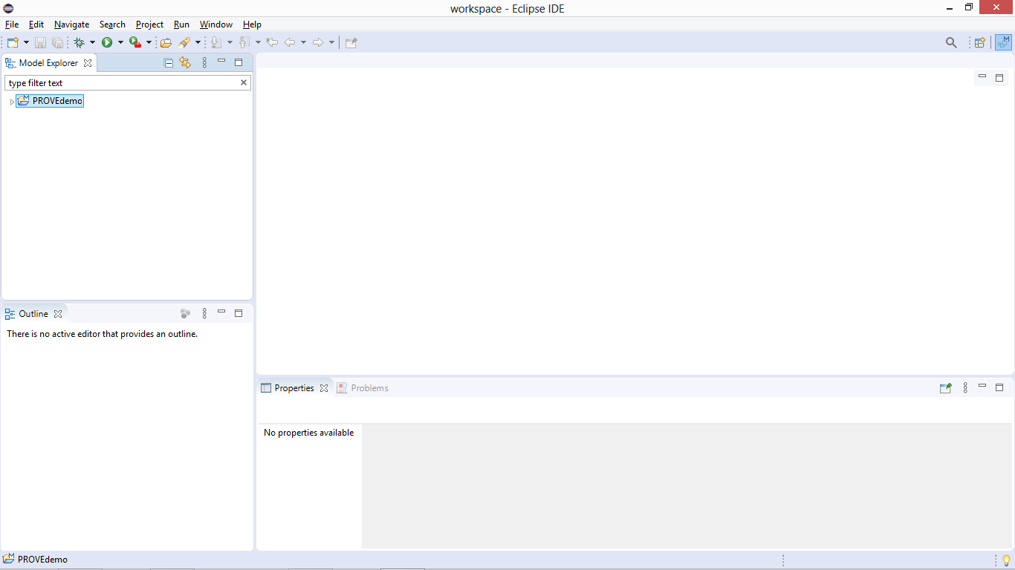

1. To create a PROVE model, right click on the new project and select New->Other…
2. Type “PROVE”, select “PROVE Model” and press “Next”.

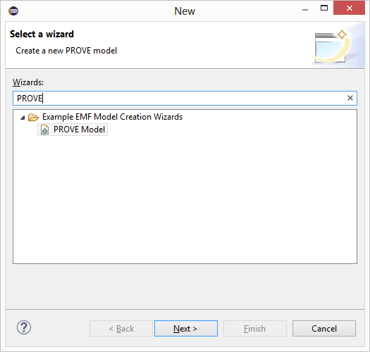

1. Name the new model (or leave the default name) and press “Finish”.

*Note:* If “Finish” is not available, click on “Next” and then select “Process” in the “Model Object” selection box, and then click on “Finish”.

1. The new model (with a seed element “Process”) should be visible in the model explorer section.
2. Right click on the project (not the model), and select “Viewpoints Selection”.

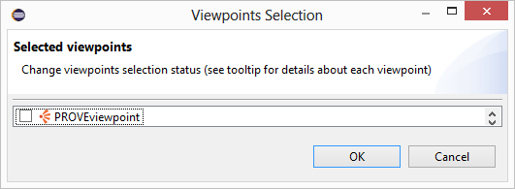

1. Select the “PROVEview” and press OK. This activates the PROVE viewpoint for the entire project. The PROVE viewpoint may be activated alongside other Sirius views.
2. If you expand the PROVE model in the Model Explorer, you should be able to see a new representation as created (“PROVE diagram”). You may double click on it to open the main PROVE modeling diagram.

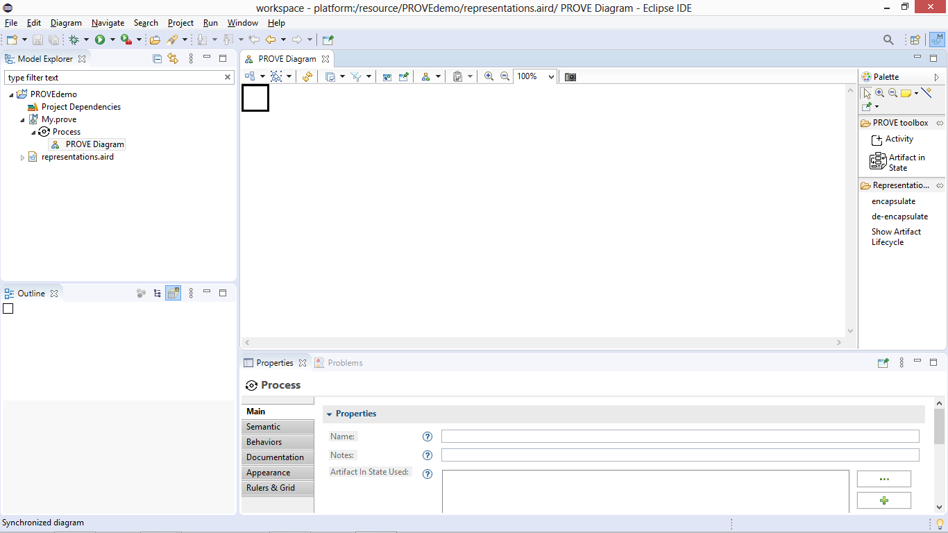

You are now ready to use PROVE. For further details on using PROVE see the dedicated presentation. For PROVE concepts and related information see <http://www.eng.tau.ac.il/~yoram/PROVEtool.html>.